**Snake**

1. Delete Sprite 1 (the cat).
2. Create a variable Score and make it visible on the stage.
3. You need to add the Pen and Music modules from the Extensions Library

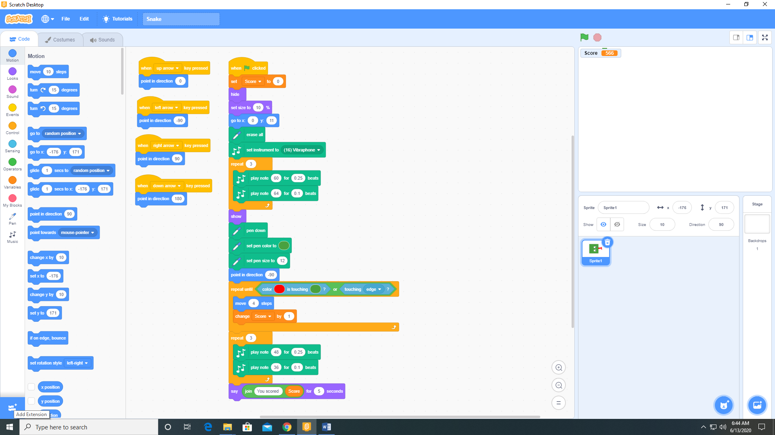 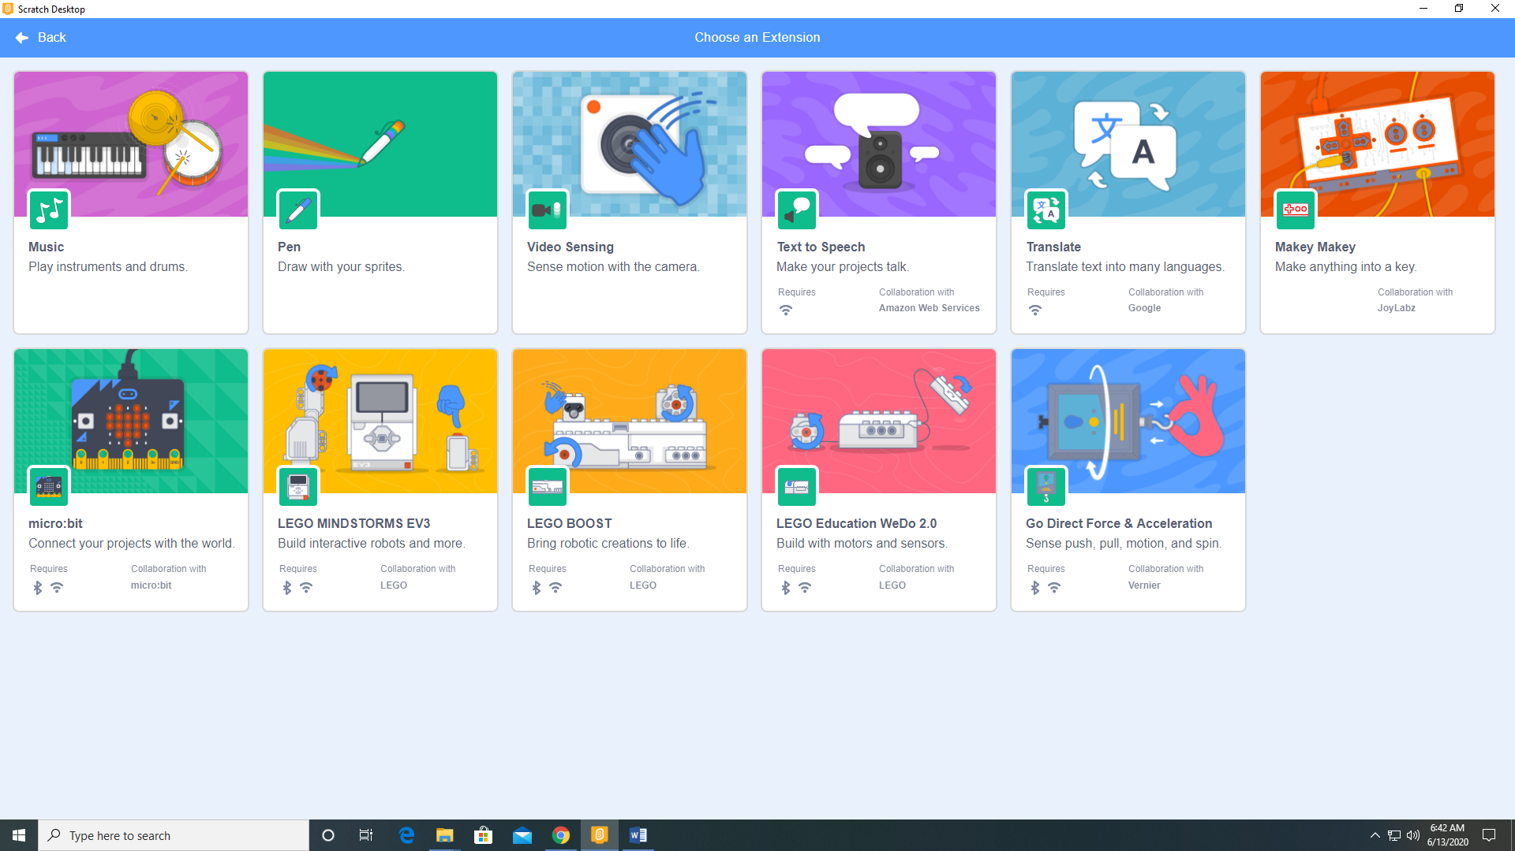

1. Paint a snake head sprite (Sprite 1) as a bitmap.

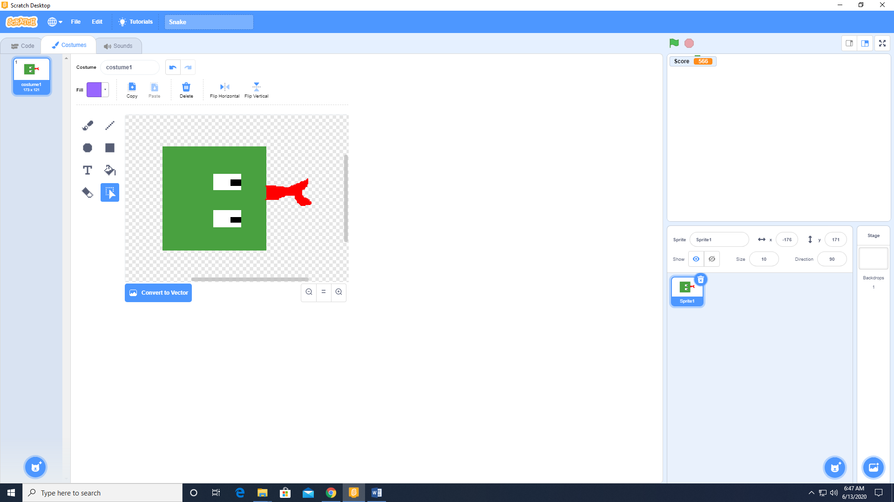

1. Add the following code to Sprite 1

